How to create Bezeichnung
- Create Viewer Instances and Query Instances for bezeichnung
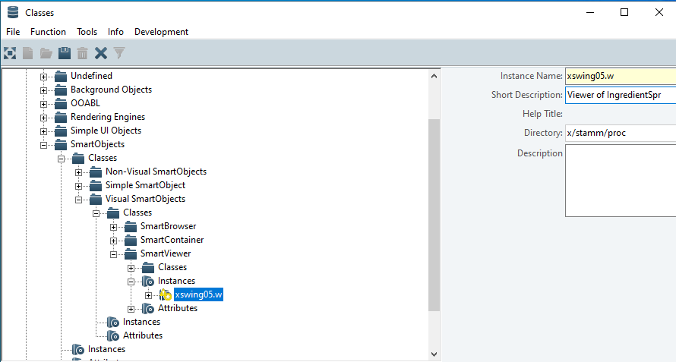
- AppBuilder > New Sprach-SmartQuery
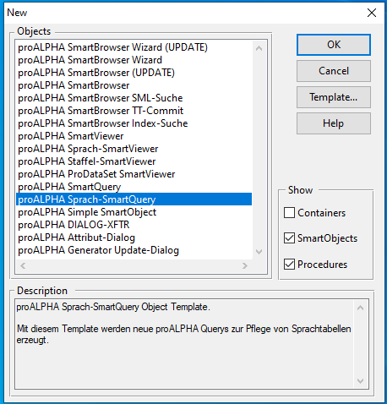

- Enter Program-Name as your instances that you created earlier (ex. xsqing05.p), Click OK, next
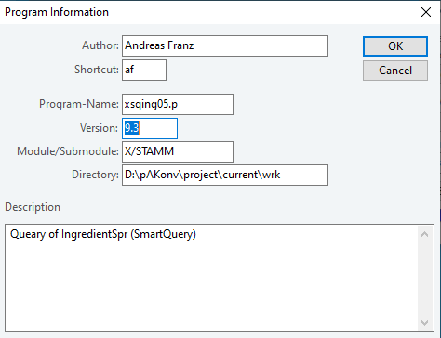
- On Page 2 click Add External Tables, select ingredient table, click OK, Next
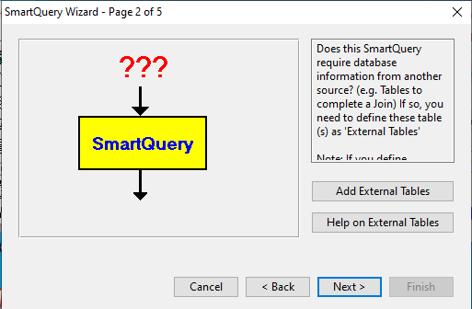
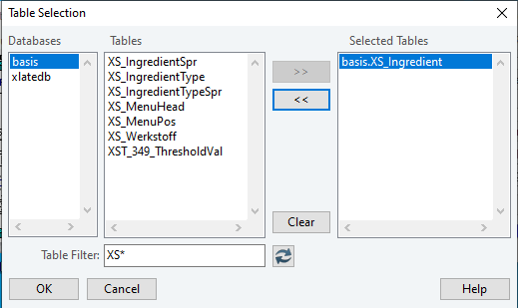

- On page 3 click Define Query, select IngredientSpr Table, click OK, next
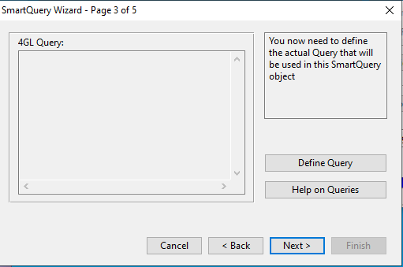
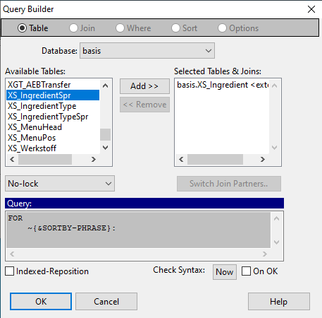

- Click on Where menu, double-click on Sprache, edit where criteria as the picture, click Ok, Next
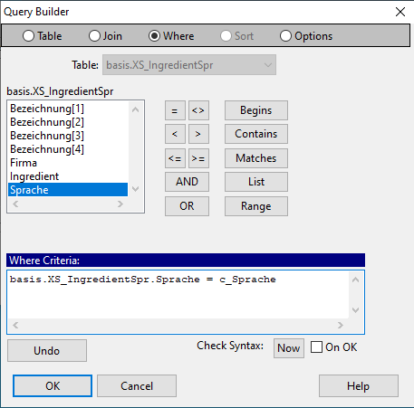
- On page 4 click Define Foreign Keys, click Insert Sindex, click OK, Next
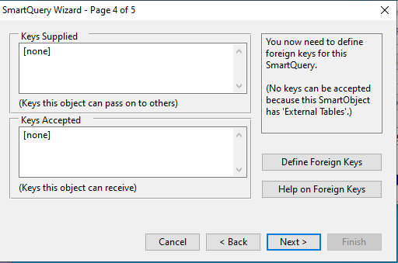
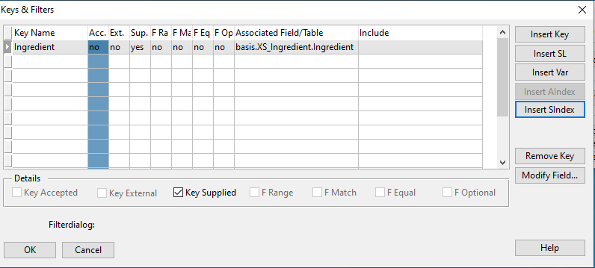
- Open your query instances in Codev, define variable c_Sprache as the picture
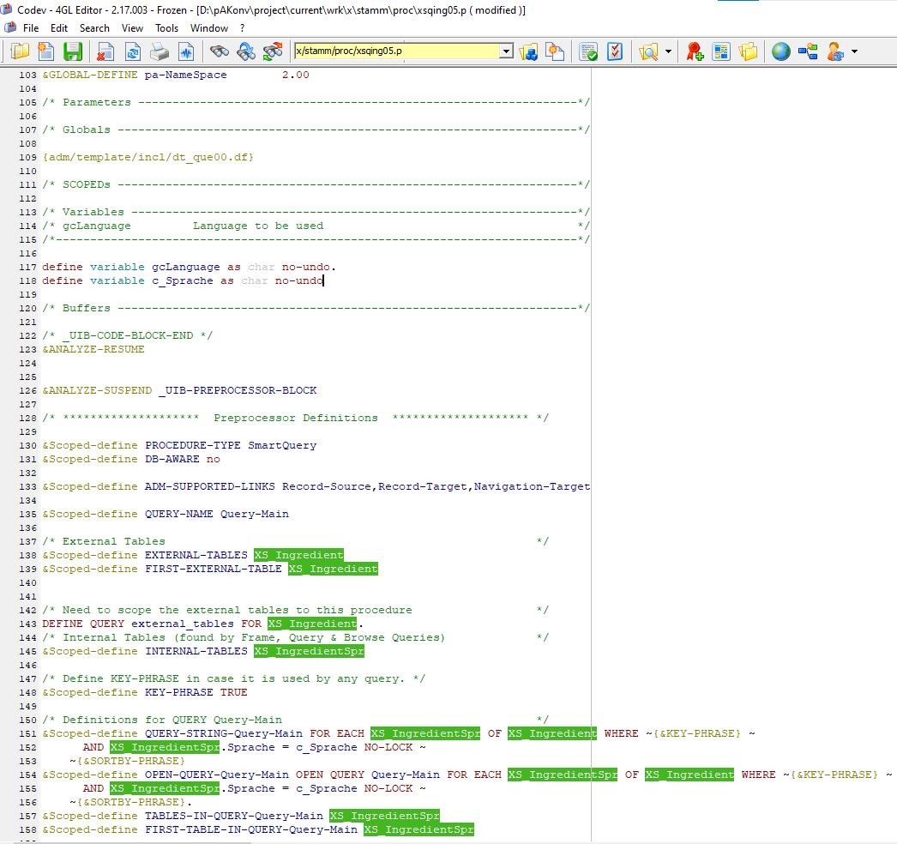
- AppBuilder > New > Sprach SmartViewer > Name your Program-Name as your viewer instances
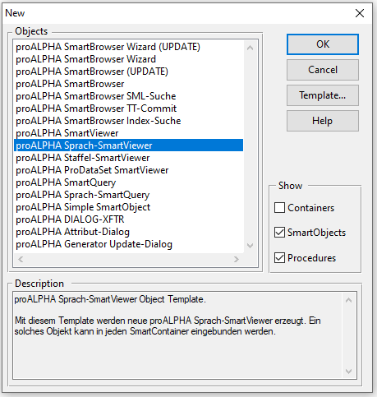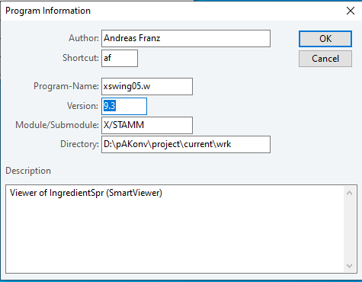

- Select IngredientSpr Table, Select the column that you want to display in your UI, adjust position, save
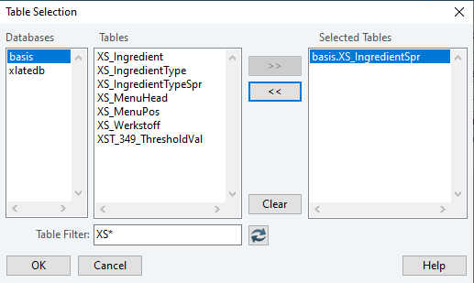
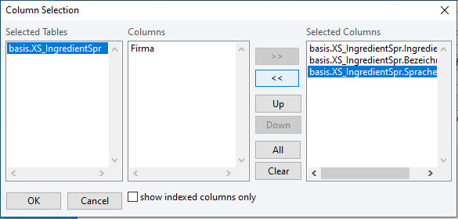
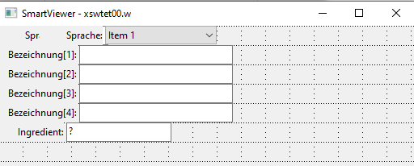

- On AB Tool call the container that you want to add Bezeichnung
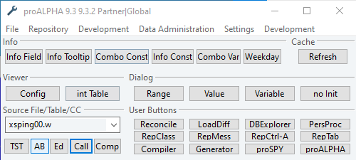

- Open Development menu and select Repository Classes
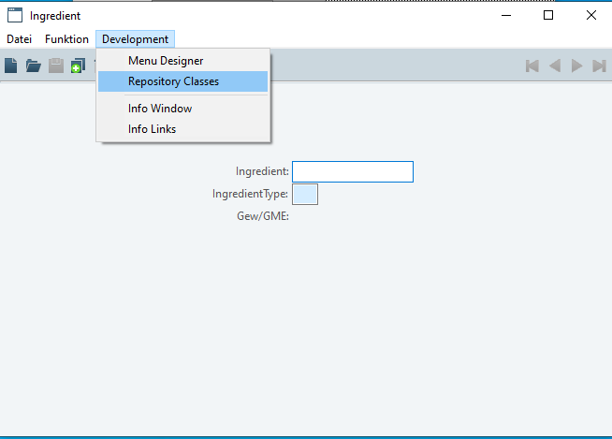
- On Repository Classes window open Function menu, select Instance Attribute Values
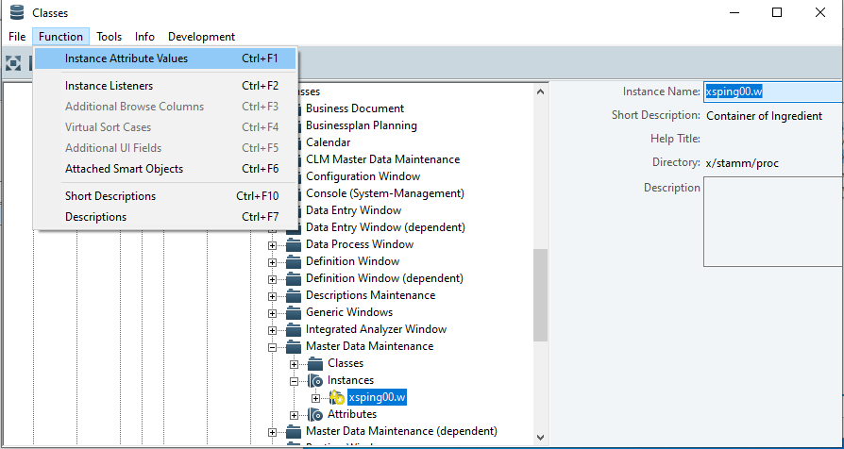

- Add Attribute Value on deprecatedSupportOldDescription = “MaintenanceProgram=d_pspr00.w,Query=stamm/proc/???????.p,Viewer=stamm/proc/???????.w”, change the query and viewer addresse to the addresse where you store your viewer and query instances earlier, save
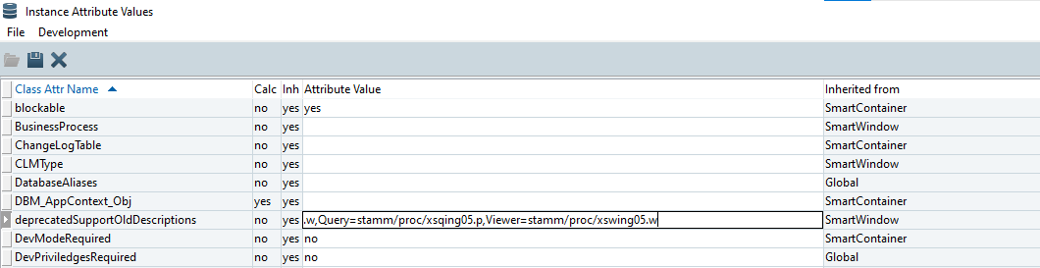

- Refresh your AB Tool, Call container, open Funktion menu, select Bezeichnungen
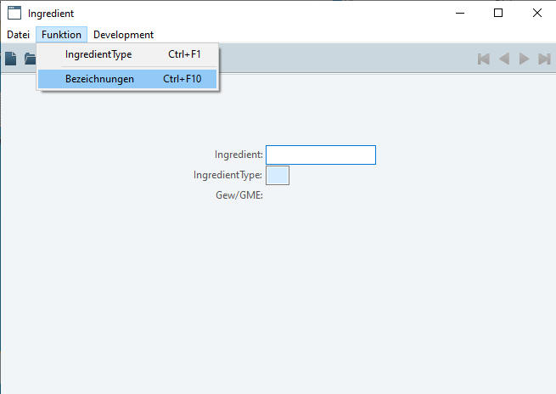
- Yahoo!
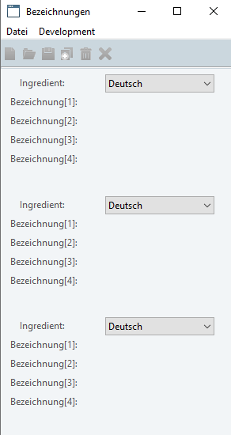

w

